**4. SYSTEM ANALYSIS**

1. **STUDY OF EXISTING SOLUTION**

The current scenario in the organization is that there is a requirement of such an application that helps to reduce paper work in storing information of interns. Current system is filed based so it is difficult to handle files and it acquires more space in organization.

**4.2 PROBLEM AND WEAKNESSES OF CURRUNT SYSTEM**

* Current system is filed based system.
* Files acquire more space in organization so it is difficult to handle and manage files.

**4.3 REQUIREMENTS OF NEW SYSTEM**

* + 1. **Functional Requirements**

a) User Login (Both admin and interns side)

Table 4.1 User Login

|  |  |
| --- | --- |
| **Input:** | Username and password (Same for admin and students) |
| **Output:** | Login successful or error message |
| **Description:** | Users will be able to log in |

b) Interns Registration (Interns Side)

Table 4.2 Interns Registration

|  |  |
| --- | --- |
| **Input:** | Fill the required details and submit. |
| **Output:** | Details will be stored in database. |
| **Description:** | Details will be securely sored in the database. |

c) Interns Profile (Interns Side)

|  |  |
| --- | --- |
| **Input:** | Login with username and password. |
| **Output:** | Home page will be displayed. |
| **Description:** | On home page intern can view his profile and can also request for a leave if he/she wants. |

Table 4.3 Interns Profile

d) Add Courses (Admin Side)

|  |  |
| --- | --- |
| **Input:** | Add course if organization introduces new course. |
| **Output:** | Course will be added into database. |
| **Description:** | If any intern is interested in the course it can be assigned to it. |

Table 4.4 Add Courses

e) Add Faculty (Admin Side)

|  |  |
| --- | --- |
| **Input:** | Admin can add new faculty by filling faculty registration form. |
| **Output:** | Details of the new registered faculty will be successfully stored in the database. |
| **Description:** | Faculty can be assigned to interns if they come under their program. |

Table 4.5 Add Faculty

f) Students Request (Admin Side)

|  |  |
| --- | --- |
| **Input:** | Whenever new intern is registered admin will come to know. |
| **Output:** | Admin will keep a track on it and will assign faculty. |
| **Description:** | To assign faculty to newly registered intern. |

Table 4.6 Students Request

g) View Interns Profile (Admin Side)

|  |  |
| --- | --- |
| **Input:** | Enter interns Id. |
| **Output:** | Interns profile will be displayed. |
| **Description:** | Admin can view students profile and can also assign work to them if needed. |

**4.3.2 Non-functional requirements**

* **Accessibility**

The application is accessible by the Project Manager (Admin) and Interns (Students).

* **Efficiency**

The application is efficient in terms of queries fired and results displayed. If Project manager enters intern’s id its details will be displayed.

* **Extensibility**

Currently the application is just for Project Manager and interns. In future it can be extended to faculty use also.

* **Privacy**

All users are given default privacy as server is there and information is secured.

* **Quality**

A good user experience is all we want. It is our primary concern to ease the complications and offer the end-user a smooth flow of service.

* **Response time**

The average response time as per rough calculations is 4-6 second.

* **Scalability**

Categories, sub categories can be added with ease.

* **Testability**

On completion of basic designing, we will out the application in the beta mode and test it with the real values that we are expecting as data in our application.

**4.4 FEASIBILITY STUDY**

The aim of the feasibility study activity is to determine whether it would be financially and technically feasible to develop the system or not. A feasibility study is carried out from following different aspects:

**Operational Feasibility:**

The system has been developed for HR. So keeping this consideration in mind we have provided field for each and every field on the forms. The HR also may be non-technical, so the user interface is designed in such a way that it gets comfortable for the non-technical person to operate easily.

**Technical Feasibility:**

It determines if the system can be implemented using the current technology. This system has been developed using Android as front end and MySQL Server as backend. This was also new to us but it didn’t take much effort and time to get used to it.

**Economic Feasibility:**

The company being a well-to-do company didn’t have any problem in buying any software that was required in developing the application. The software’s we used were readily available. So as such we didn’t face any economical constrains.

**4.5 Use Case:**

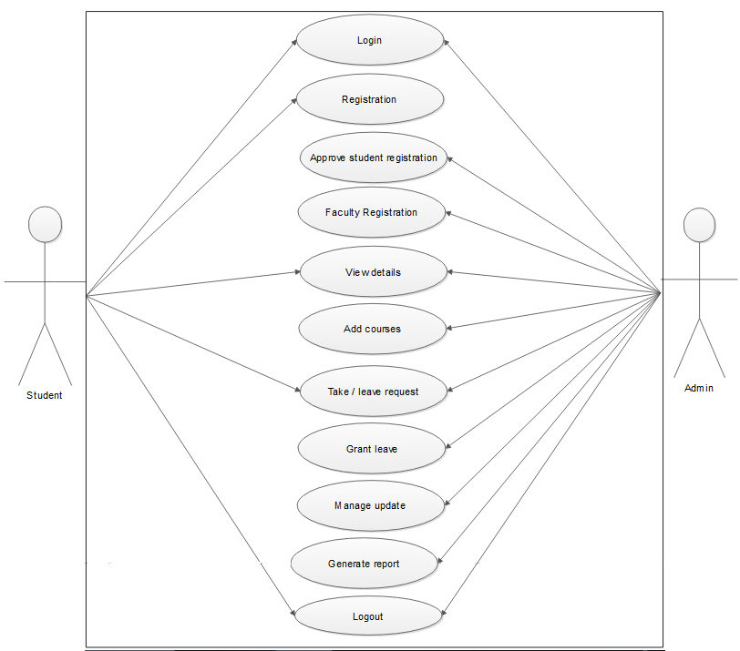

Fig: 4.1 Use Case Diagram

**4.6 Sequence Diagram**

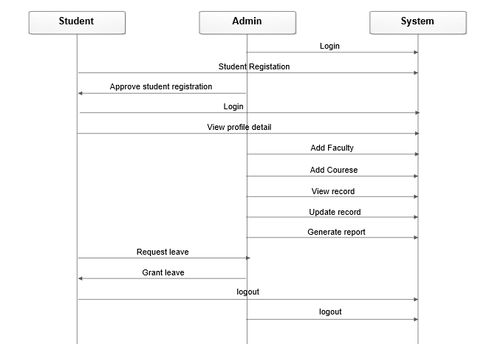

Fig 4.2 Sequence Diagram

**4.7 System Work Flow**

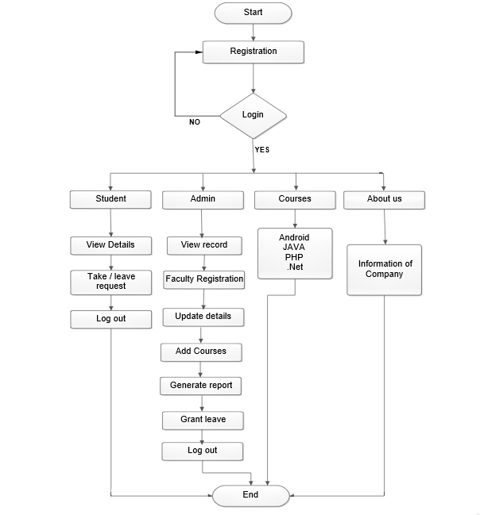

Fig 4.3 System Work Flow

**4.8 Activity Diagram**

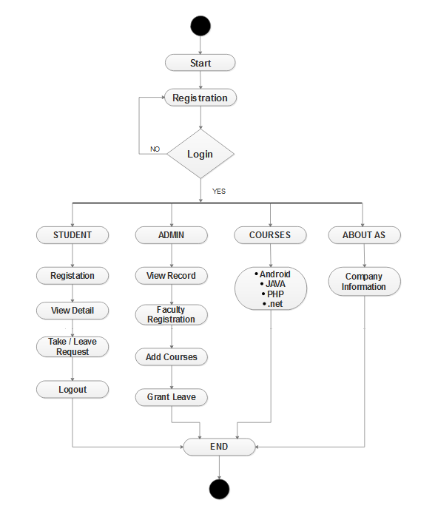

Fig 4.4 Activity Diagram

**4.9 ER Diagram**

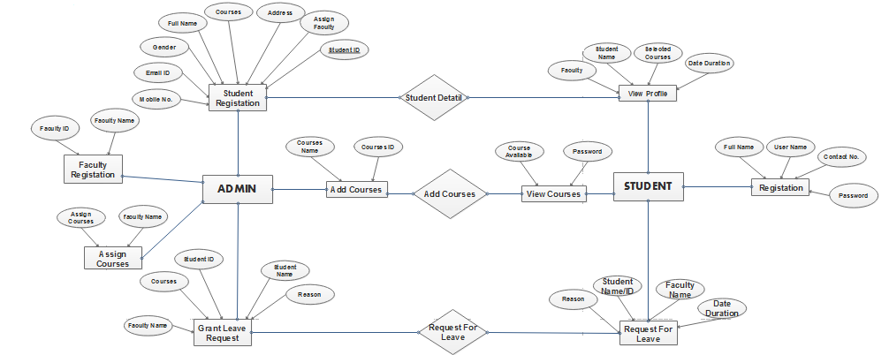

Fig 4.5 ER Diagram

**4.10 Data Flow Diagram:**

4.10.1 0-Level:

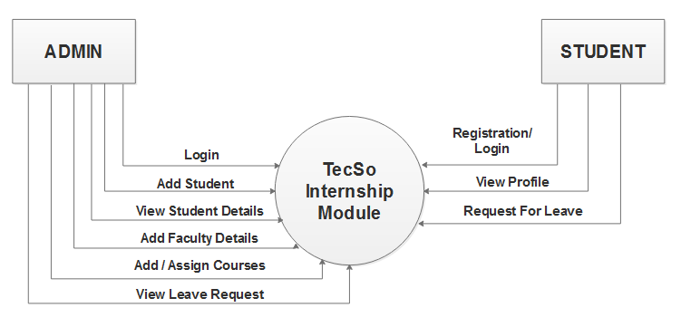

Fig 4.6 0-Level

4.10.2.1-Level:

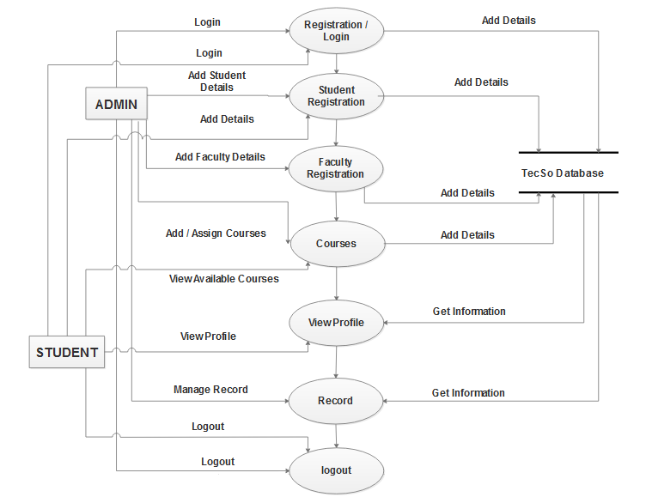

Fig 4.7 1-Level